Flow Connect - Content plan template

Objectives

Content pillars

Date | Content pillar | Platform | Copy (text) | Media (graphic/image/video) | Status
8 Nov
Wed
9 Nov
Thurs
10 Nov
Fri
11 Nov  Sat | National day | LinkedIn | Veterans Day | 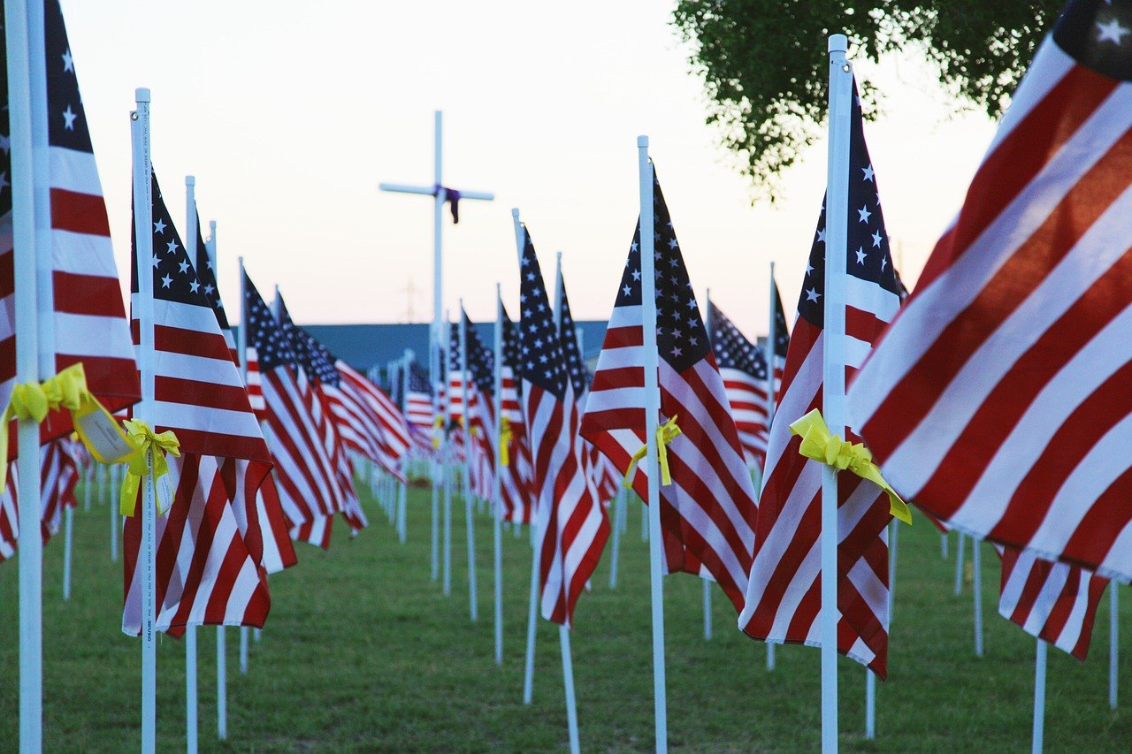  Pixabay
12 Nov
Sun
13 Nov
Mon
14 Nov  Tues | International health day |  | World Diabetes Day
15 Nov
Wed
16 Nov
Thurs
17 Nov
Fri
18 Nov
Sat
19 Nov  Sun |  |  | World Toilet Day
20 Nov  Mon |  |  | World Children’s Day
21 Nov
Tues
22 Nov
Wed
23 Nov  Thurs |  |  | Thanksgiving
24 Nov
Fri
25 Nov
Sat
26 Nov
Sun
27 Nov
Mon
28 Nov  Tues |  |  | Giving Tuesday
29 Nov
Wed
30 Nov
Thurs

